COM161 – Practical 10

The purpose of today’s practical is to use a super-class (parent) and subclasses (child)

Scenario

You will create a superclass and three subclasses. The Shape superclass will have generic properties. These will ultimately hold the areas and boundary lengths of your shapes. The superclass will also count how many Shapes have created.

The three subclasses you need to write are called Square, Circle and Triangle (this will be a right-angled triangle with both the opposite and adjacent sides having the same size).
- These three subclasses should have methods which allow for the calculation of the Boundary length and for the Area of the shape.
- An application class should be developed which allow for the user to select a shape and enter in a dimension.
- An instance of the selected shape type will be used to calculate the boundary length of the shape and its area based upon the entered dimension.
- The program should print out these two pieces of information and ask the user if they wish to perform more calculations.
- The program should also output how many generic Shapes were created and how many individual Circles, Triangles, and Squares were created as well.

See the second last page of the practical for how the area and boundary lengths of the relevant shapes are calculated.

Scenario

Part One – The Super class

Create a Shape superclass. It will have the following

- Two instance properties – area and boundary. These will ultimately hold the areas and boundary lengths of your shapes.

- A class property called count. This will record how many times an instance of the Shape class has been created. Note that this class property is ‘private’. Determine the best approach to access this property.

- Two instance methods – getArea and getBoundary These will take in parameter that will represent the dimension entered in by the user. Both methods should return 0.

Note if this completely flummoxes you, the answer is at the back (but please attempt the super class first).

Part Two - The Subclasses

Step 1
Write a subclass called Square. This will extend the Shape class.

- Declare a class property called countSquare. This will record how many times an instance of the Square subclass has been created. Determine the appropriate access modifier for this property
- Override the two instance methods you wrote in the superclass. The first method should return the “area” of the square instance and the second should return the “boundary” of the square instance.

Step 2

Create a program that will create an instance of Square.

- Prompt the user to read in a dimension.
- Print out the area and boundary of the Square.
- Print out how many times an instance of the Shape class has been created
- Print out how many times an instance of the Square class has been created

Step 3

Once you have tested the Square subclass, create two new subclasses called Triangle and Circle. Follow the guidelines in Step 1.

Step 4

Amend your program by implementing a menu system.

- The user should be prompted for which shape they want to find the area and boundary length of.
- Once this choice has been read in, create an instance of the relevant shape and then output the area and boundary length of the shape.
- Once this is done, prompt the user to see if they want to calculate the area and boundary of another shape.
- At the end of the program output how many Shapes were created and how many individual Circles, Triangles, and Squares were created as well. See the screenshot on the following page as to how your code could look when run

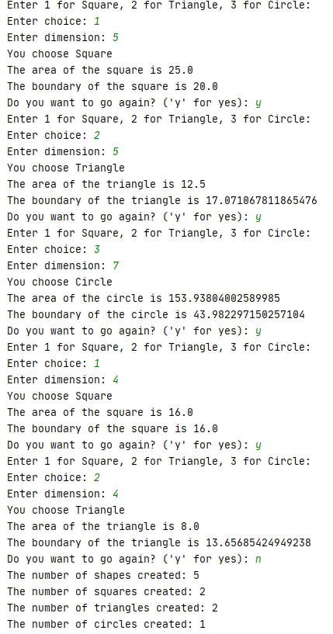

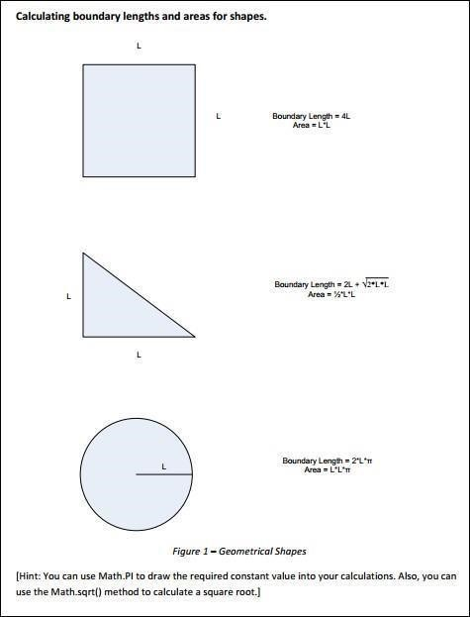

Shape superclass

